Incoming 7th French Summer Work 2024

Grammar Review:

- Explore 15 new nouns- find out their French translation and complete the following chart

NEW NOUN (English & French translation) | Definite article  (Singular & Plural) | Indefinite article (Singular & Plural) | Possessive article (MY) (Singular & Plural) | Possessive article (YOUR) (Singular & Plural) | Possessive article (HIS/HERS) (Singular & Plural)
Car voiture (f) feminin | LA/LES | UNE/DES | MA/MES | TA/TES | SA/SES

- Choose 10 verbs from the REGULAR ER VERB CHART – conjugate all 10 verbs using all the French Subject Pronouns – see below chart that you will recreate!

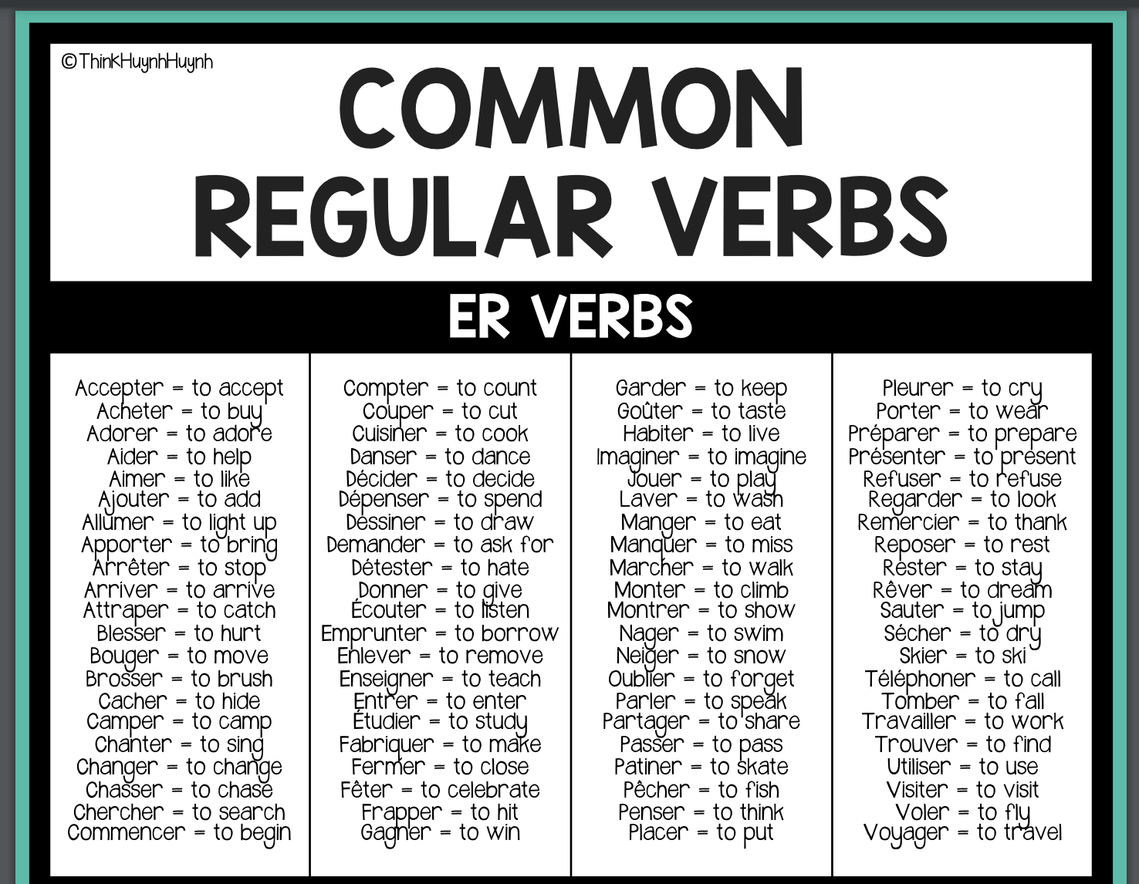

JE | NOUS
TU | VOUS
IL/ELLE | ILS/ELLES

LISTNING:

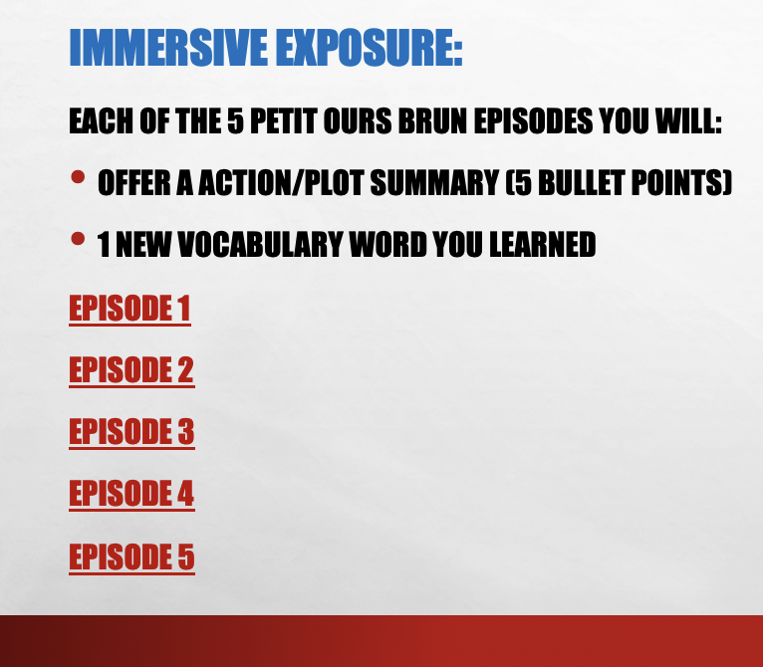

READING:

